12 Way Vertically Mounted Rackmount IEC PDU - UK Sockets (PDU-12WS-V-UK-IEC)

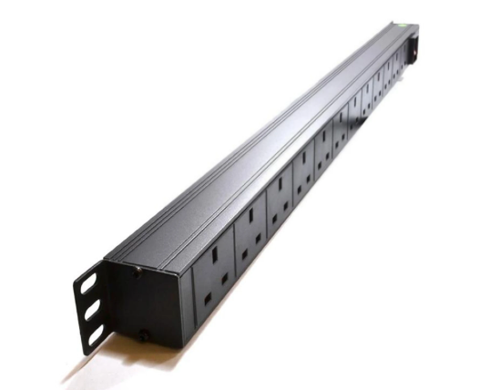

Description:

The LMS Power PDU-12WS-V-UK-IEC is a high-quality vertically mounted PDU (Power Distribution Unit) that simply fits within the universal mounting brackets of data, telecom and server cabinets.
A must-have accessory for your data cabinets if you need to provide effective power to devices including Ethernet Switches, Servers, UPS, NAS and of course cabinet accessories including cooling fan trays.
Robust, alloy design complete with rackmount brackets fitted, high-quality Neon Switch and of course UK output sockets together with a high quality, certified IEC-14 power input plug.

Key Features:
Standard UK 3-Pin power outlets for your appliances
Certified IEC-14 power input plug
1U high means the PDU can fit into the smallest cabinet
Neon On/Off Rocker switch to prevent accidental turn off
Backed up by LMS Power's exclusive 3-year warranty

Applications:
Create instant power feeds to your data, telecom or server cabinets
Provide effective power for cabinet cooling fans, UPS systems
Ideal as stand-alone trailing sockets outside the cabinet

Product Code:
Part Number: PDU-12WS-V-UK-IEC
EAN: 8400800024244
Weight: 1.1Kg approx

Technical Specifications:
Warranty LMS Data 3-Year Warranty
Chassis 1U vertical mount with mounting brackets
Output Sockets 12 UK 3-PIN Sockets
Power Input Fitted IEC-14 Plug
Flex Length 1.8 metres (approx)
Power Control On/Off Rocker Switch (illuminated)
Power Rating 4000 Watts (approx)

Supplied With:
PDU-12WS-V-UK-IEC 12 Way Vertical PDU
19-inch cabinet brackets (Fitted)
* Specifications and product design are subject to change. E&OE.

Looking for a more specialised Power Distribution Unit (PDU) with high-density power output sockets? The new LMS Data PDU-12WS-V-UK-IEC is a high-density, vertical placement PDU which features 12 standard UK power socket outlets to provide power to networking, data centre, PBX and broadcast level power devices within the data cabinet enclosure. Setting this high-performance PDU apart is the inclusion of an industry standard IEC (IEC14) connector on the generous 1.8 metre (approx.) trailing mains input cable. Long enough for deployment in almost any scenario of data cabinet enclosure and as an added feature comes standard with mounting points for quick and easy fitment. Coupled with a long-life, illuminated I/O Switch and a robust, aluminium-type enclosure means the PDU-12WS-V-UK-IEC is ideal for a whole host of professional applications, today and in the future.

specifications:
12-way, UK plug-socket style Power Distribution Unit (PDU)
Compliant, 13-amp UK 3-pin socket output
Compliant, performance IEC (IEC14) plug input
Illumination On/Off power-input rocker switch
Generous length, 1.8 metre (approx.) power cable
Lightweight design with a 1U high form-factor design
Ideal for vertical placement in data or server enclosures
Ideal for LAN, audio-visual, PBX, VoIP and CCTV applications

